## **HTML Task**

**Note:** After completing each task, save your changes in index.html and refresh your webpage in your browser to see the updates.

### List Example:

* Open index.html in your IDE.
* Locate the "List Example" section.
* Added <ul> under the existing <ol>..</ol>.
* Inside the <ul>, add list items (<li>) as needed with square bullet style.  
    
  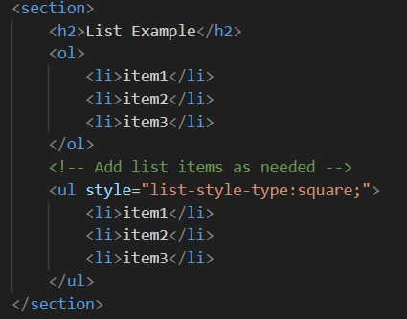

### Table Example:

* Find the "Table Example" section in index.html.
* Update the table to include a new row (<tr>) after the existing rows.
* In this new row, add a single <td> element that spans across both columns (colspan="2").  
    
  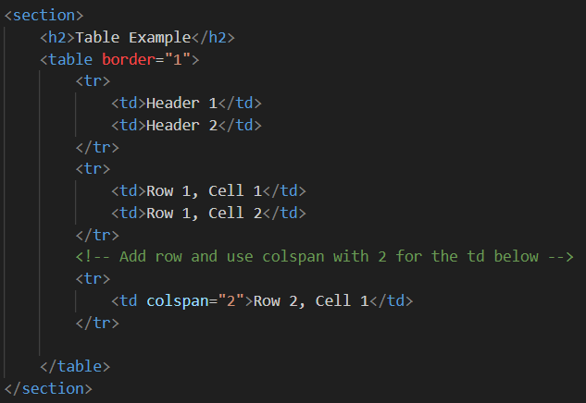

### Navigation Example:

* Navigate to the "Navigation Example" section in index.html.
* Add hyperlinks for navigating to page1.html and page2.html.
* Use descriptive text such as "SamplePage1" and "Visit SamplePage2" for the hyperlinks.  
    
  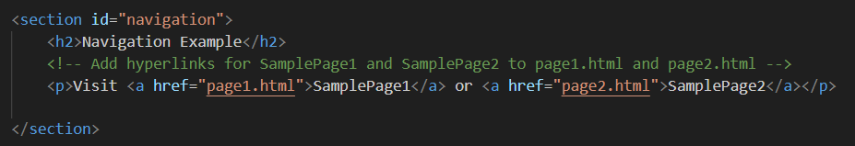

### Form Example:

* Locate the "Form Example" section in index.html.
* Enhance the existing form by adding a new input field for the user's phone number along with label as **Phone**
* Include a corresponding <label> for this new input field.  
    
  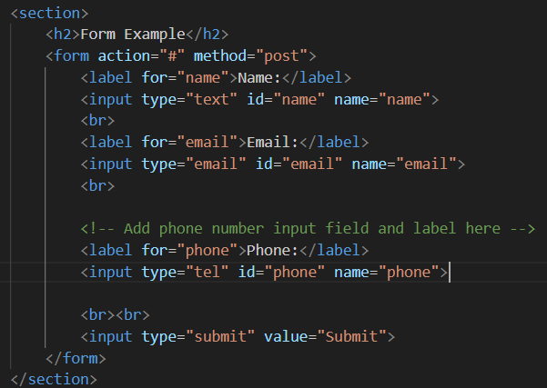

## **CSS Task**

**Note:** After completing each CSS task, remember to save your changes in styles.css and then refresh your webpage (index.html) in your browser.

### Header styles:

* Open styles.css in your IDE
* Apply dark background color #333 and text color #fff to the header (header).
* Center align the text and add padding of 10px within the header

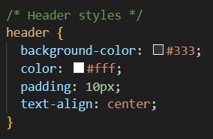

### Main Content Styles:

* Set padding of 20px for the main section.  
    
    
  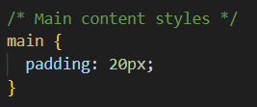

### Form Input Styles

* Select and style <input> elements of types text, email, and tel.
* Ensure these inputs have a width of calc(100% - 22px) to accommodate padding and borders, a padding of 10px, margin of 5px 0 10px, a 1px solid border with #ccc color, border-radius of 4px, and include padding and border in the total width (box-sizing: border-box).  
    
  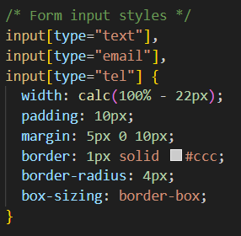

### Footer Styles:

* Include a dark background color #333, text color #fff, centered text alignment, 10px padding, fixed position at the bottom (position: fixed), full width (width: 100%) and add bottom: 0 to keep it at the very bottom of the page.  
    
  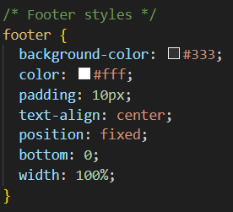

### Enhanced Task - Input Submit Button Styles

* Find the section labeled **"Enhanced Task: Input Submit Button styles"**.
* Uncomment the CSS properties/rules for input[type="submit"] and input[type="submit"]:hover  
    
  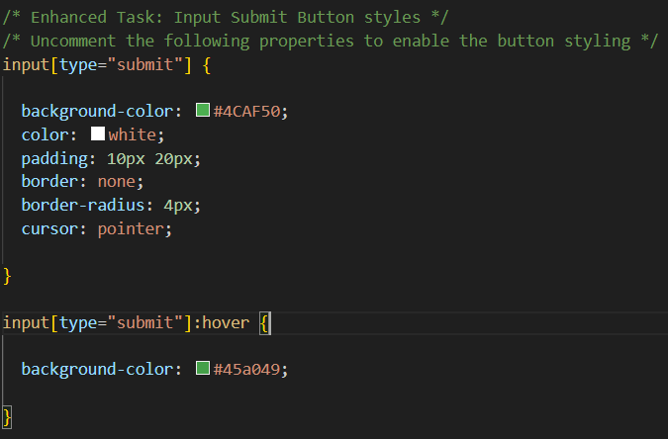

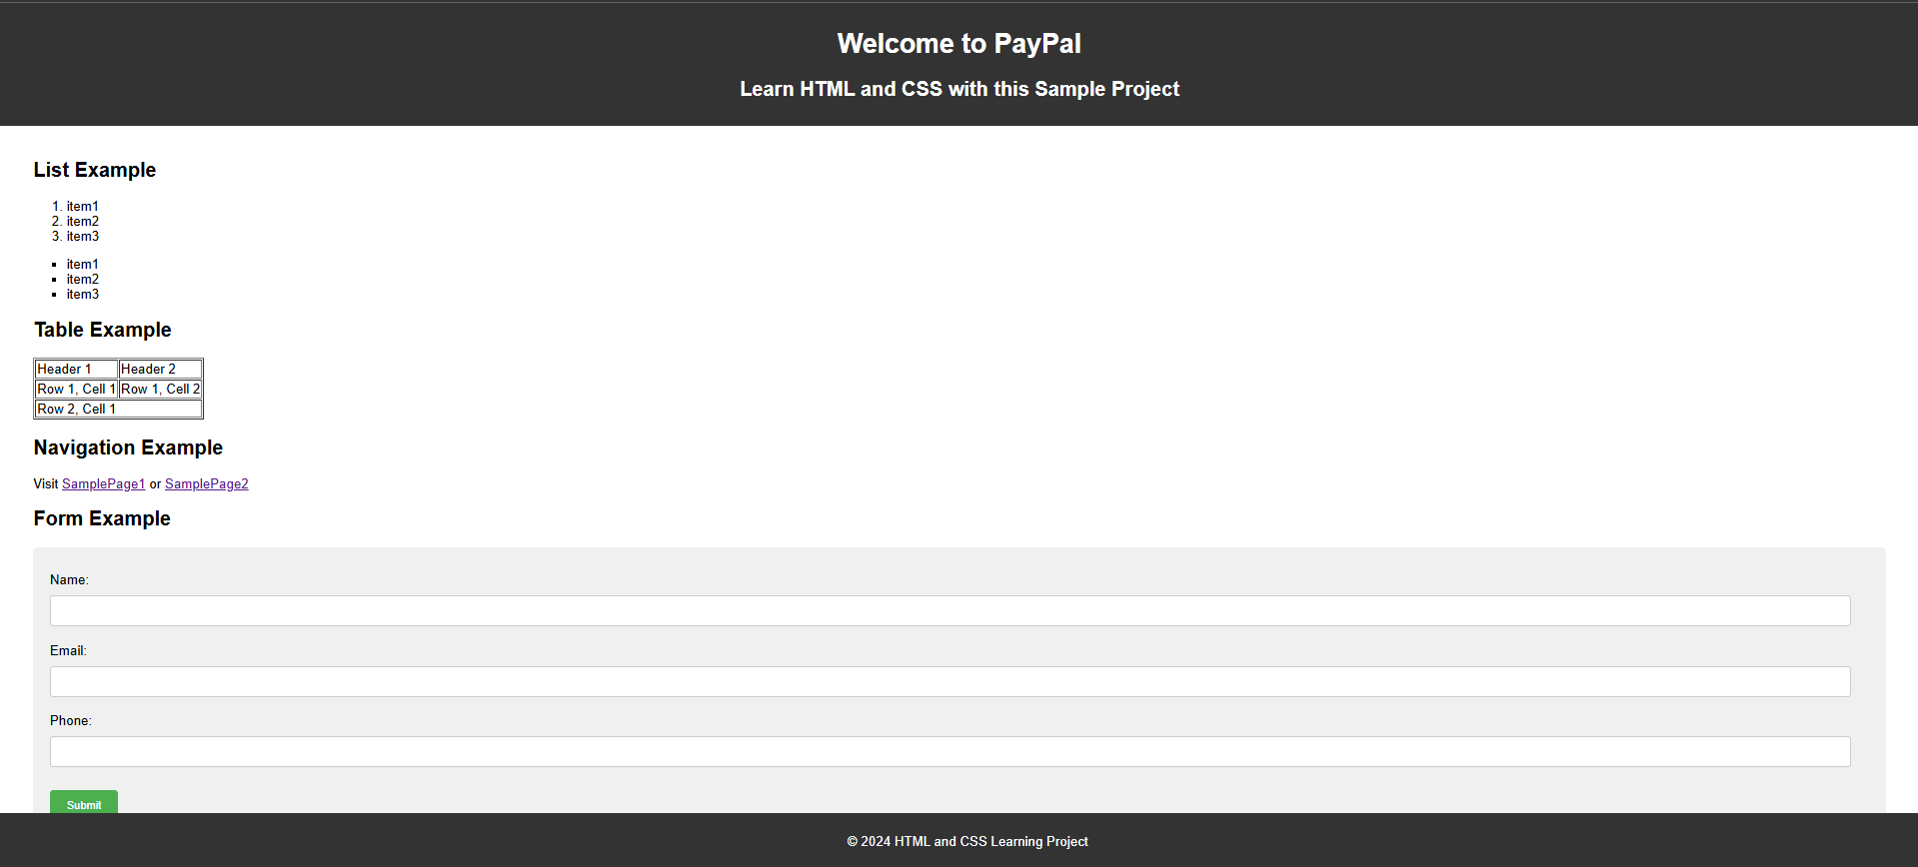

**Git & IntelliJ Assignment**  
  
  
Explain the following questions in two simple sentences

1. What is the use of the git add command?

The git add command adds the new or modified files to the staging area of the git which will be included in the next commit. It tells Git which files you want to track. Without it, the git commit command would never work.

1. Write the command to create a branch “feature-group”.

git branch feature-group

1. What is a pull request? Write the steps involved in creating a pull request.  
     
   A pull request is a method for suggesting changes to a repository. It makes collaboration easier as you can merge code of other members from one branch into another (usually the main branch). This could be adding new features or modifying the existing ones.  
     
   Steps Involved:  
   i) Fork or clone the repository.  
   ii) Create a new branch using ‘git branch branch-name’.  
   iii) Make and commit changes to that branch.  
   iv) Push the branch to your forked repository.  
   v) Go to the original repository.  
   vi) Click “Compare & pull request” and add a title and description.  
   vii) Choose the correct branches (base and compare).  
   viii) Create the pull request for review and merging.
2. How do you add collaborators?  
     
   Steps Involved:  
   1. Go to desired repository on GitHub  
   2. Click on the "Settings" tab  
   3. In the sidebar, select "Collaborators”  
   4. Click on “Add people”  
   5. Enter the GitHub username or email of the person you want to add  
   6. Set the role/permission  
   7. Click “Add”.
3. What is the command used to commit our changes in github repo?  
     
   git commit -m "message"
4. Create a github account and repository to save all your assignment tasks. Example repository name: rg-assignments  
     
   <https://github.com/AdiG08/RG-Assignments>
5. Create a branch called feature-java(you can use it later to push all your java related tasks to this branch)
6. Install IntelliJ IDE. Create a simple java project displaying “Hello World!!”and share the screenshot.  
     
   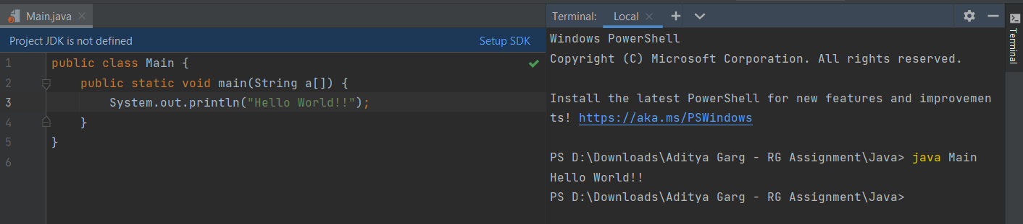
7. In IntelliJ IDE, explore the shortcut keys for the following
   1. To run the project - Shift + F10
   2. To select a line - Ctrl + W
   3. To comment/uncomment a line - Ctrl + /
   4. To delete a line - Ctrl + Y or Ctrl + delete (to delete word by word)